Jana Nash-Siegle
ASL – 021601
November 7, y

Project/App Title:
Healthy List

Project/App Summary:
This app will allow for creation of a grocery list and each item can be edited, updated or deleted. User will be able to register via the app or login with facebook.

Twist:
You will not only be able to create/edit/save the list.

Create 4-week progress schedule and show featured that will be completed every week.

Example:

Week 1 Schedule:
Monday-Tuesday: Research / Class Basics
Wednesday-Thursday: Development Environment SetUp/ PRD / Preliminary “Hello World” completion. | Begin 2nd Week Development Bootstrap
Friday-Sunday Continue Code Development (HTML/CSS etc), Database Completed
Week 1 Deliverables:
PRD and Laravel Installed | Tested | Beginning Project Uploaded to GitHub

Week 2 features:
Login – User can create account, login to account and logout from account. (1)
Add Facebook login (2)
BootStrap (3)

Week 2 Schedule:
Mon-Sat - Layout Pages with Bootstrap/Base | Login/SignUp | Begin CRUD | Code Code Code
Sunday: Turn in Deliverables

Week 3 features:
CRUD – Create List, Add Items to List, Delete Items from List (4)

Week 3 Schedule:
Complete any unfinished work from Week 2.
Begin List Creation | Edit | Deletion | Save multiple lists

Week 4 features:
Possible Search Function (5)
Jquery Plugin (6)

Week 4 Schedule:
Complete any unfinished work from previous weeks.

Project Specs:
Landing Page
LogIn Page
User Page
User Information
Grocery List
Create, Update and Delete within list.

Wire Diagrams:

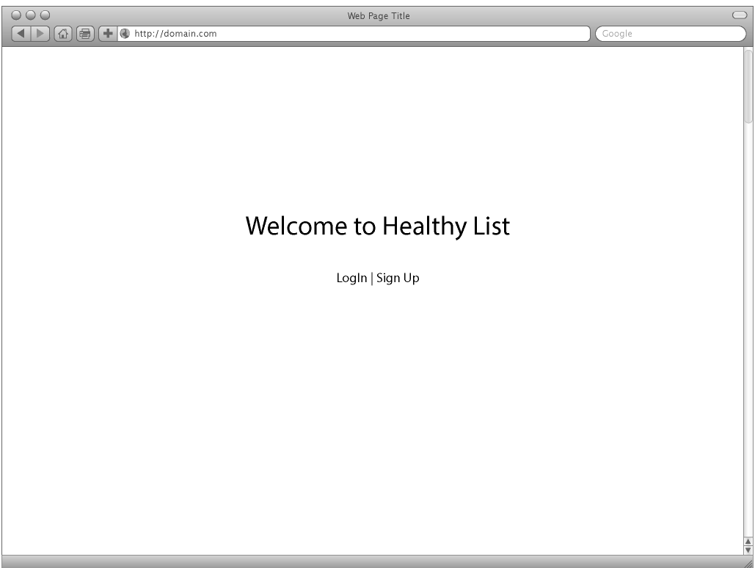
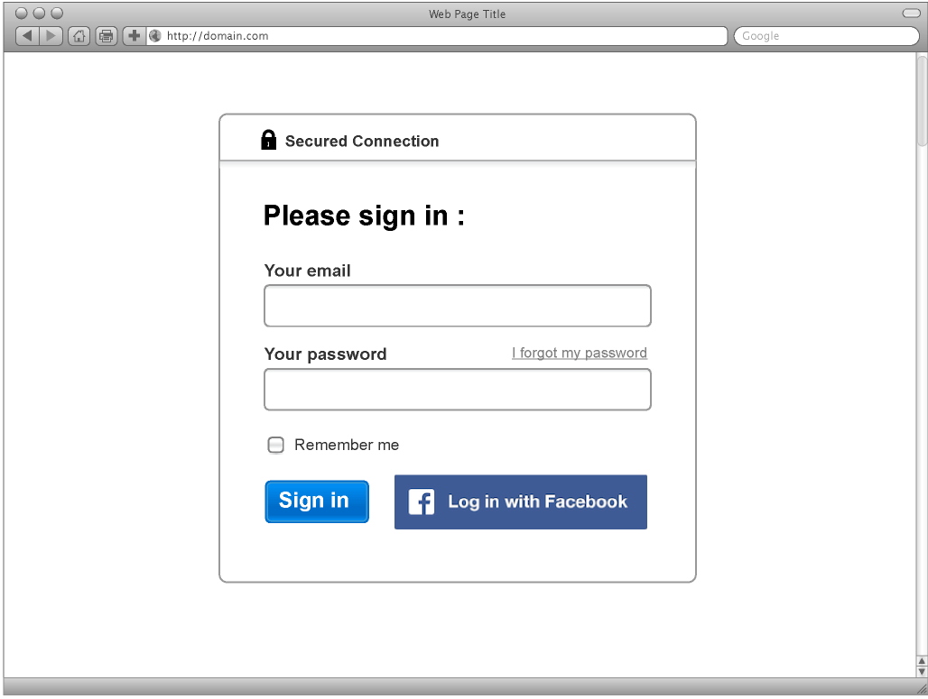

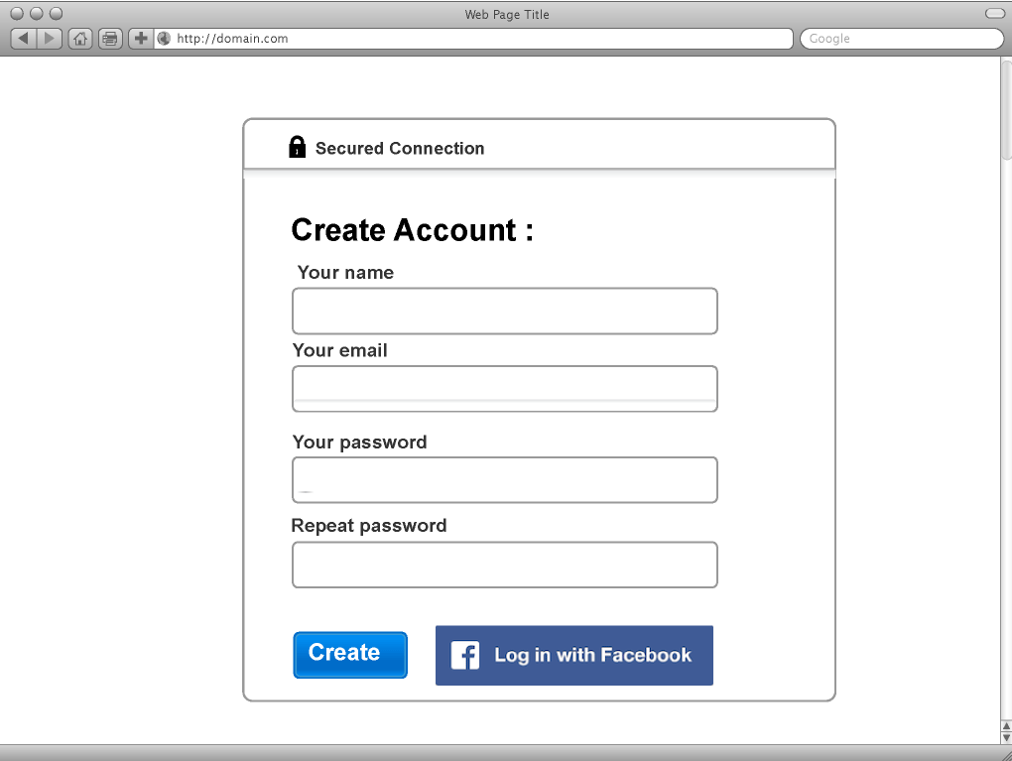

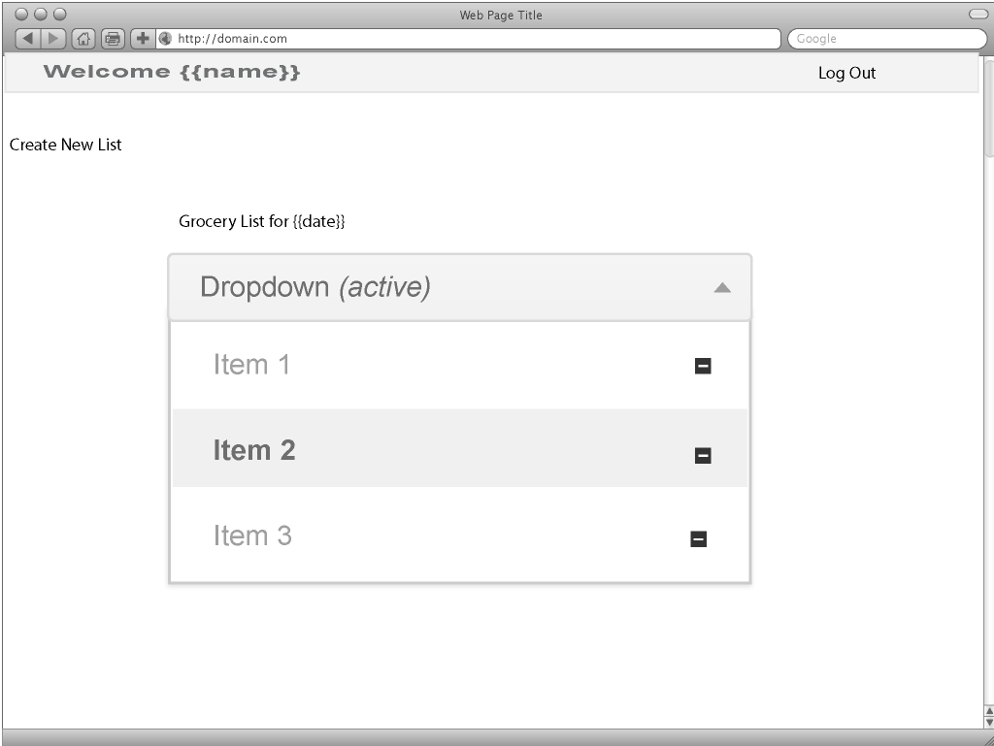

Color Scheme:

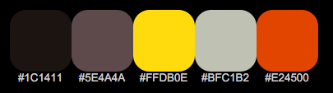

Database Diagram:

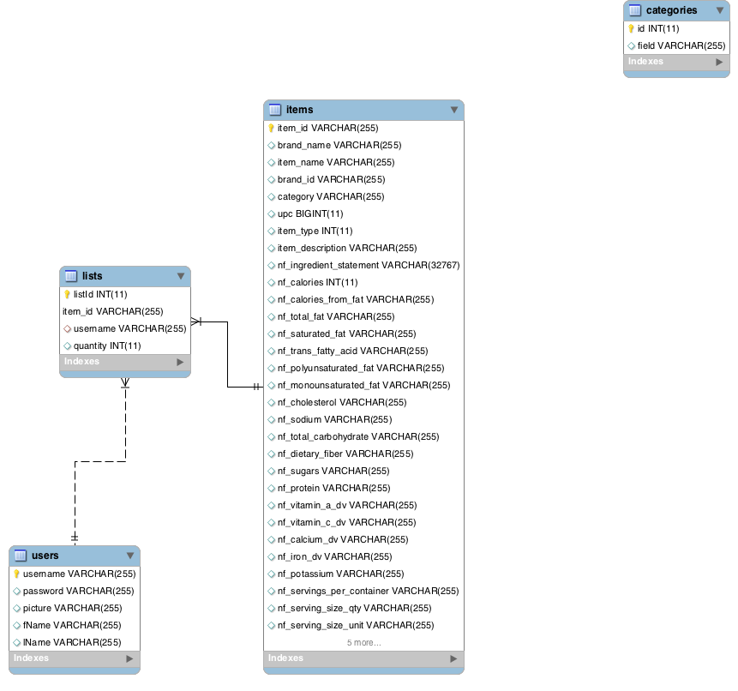
Language and framework:
PHP and Laravel and Bootstrap.

Version one:
Use of a jquery plugin | bootstrap layout, CRUD, login and facebook option for login, Search, Reset Password, internal database for form data

Version two:
Restaurant information, Grocery Store Search.

